Memorial Donation Form
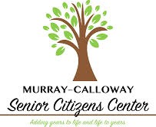 | Murray Calloway County Senior Citizens, Inc.  Our mission is to encourage and support senior citizens in leading independent, fulfilling lives in their own homes and to provide an atmosphere that is conducive to their mental, physical, and emotional well-being.

Donor Information (please print or type)

Name:

Address:

City, ST, Zip Code:

Telephone Number:

Email Address:

In Memory of _________________________________________ I (we) donate:
$__________________________________
I (we) make this donation in the form of: ☐cash ☐check ☐Pay Pal ☐other.
Gift will be matched by (company/family/foundation)
☐form enclosed☐form will be forwarded

Acknowledgement Information
Please use the following name(s) in all acknowledgements:
________________________________________________________________________________________________________________________

☐I (we) wish to have our gift remain anonymous.
Please make checks, corporate matches,  or other gifts payable to:  Murray Calloway County Senior Citizens Center |  | Murray Calloway County Senior Citizens, Inc.  607 Poplar Street  Murray, Kentucky 42071

